|  |  |  |  |  |  |
| --- | --- | --- | --- | --- | --- |
| Date | 12-Dec-22 | | | Tester Name | Mohammad Yusuf |
| Environment | Penfax - Test | | | Login used |  |
| Operating System | Windows | Version: | Update: | | |
| Software Used | Edge | Version: | Update: | | |
| Not Applicable | Version: | Update: | | |
| Release version |  | | | | |
| Title | E6 Contributions | | | | |
| Test Type | Regression | | | | |
| Test Scenario | E6.04 Post SIN Contribution via uploading a file | | | | |
|  |  | | | | |
| Expected Results | Contribution amount should be available under Contribution History, Payroll History and Account Activity.  Contribution amount should be included in PEPP Valuation Report by employer name and the funds. | | | | |
| Pass/Fail | Pass | | | JIRA# | N/A |

Describe your steps with screenshots:

1. Log into Employer PLANet (DCT) and select an employer from the dropdown for whose employees you want to process the contribution.

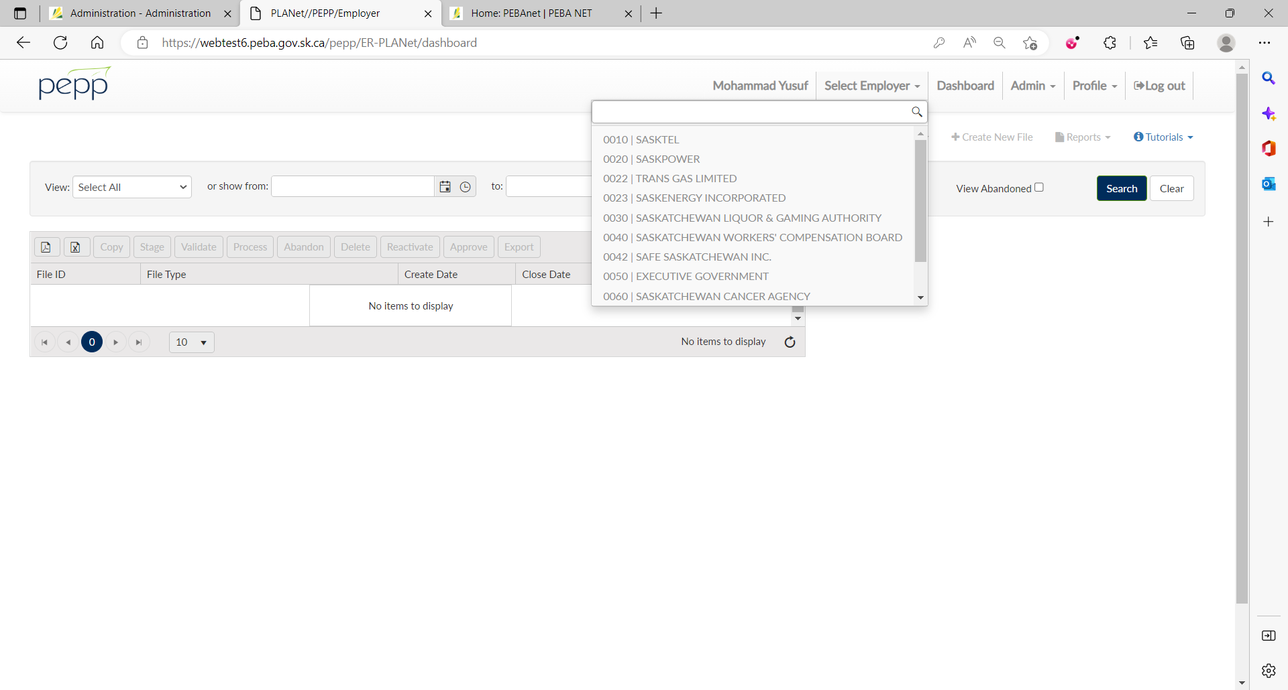

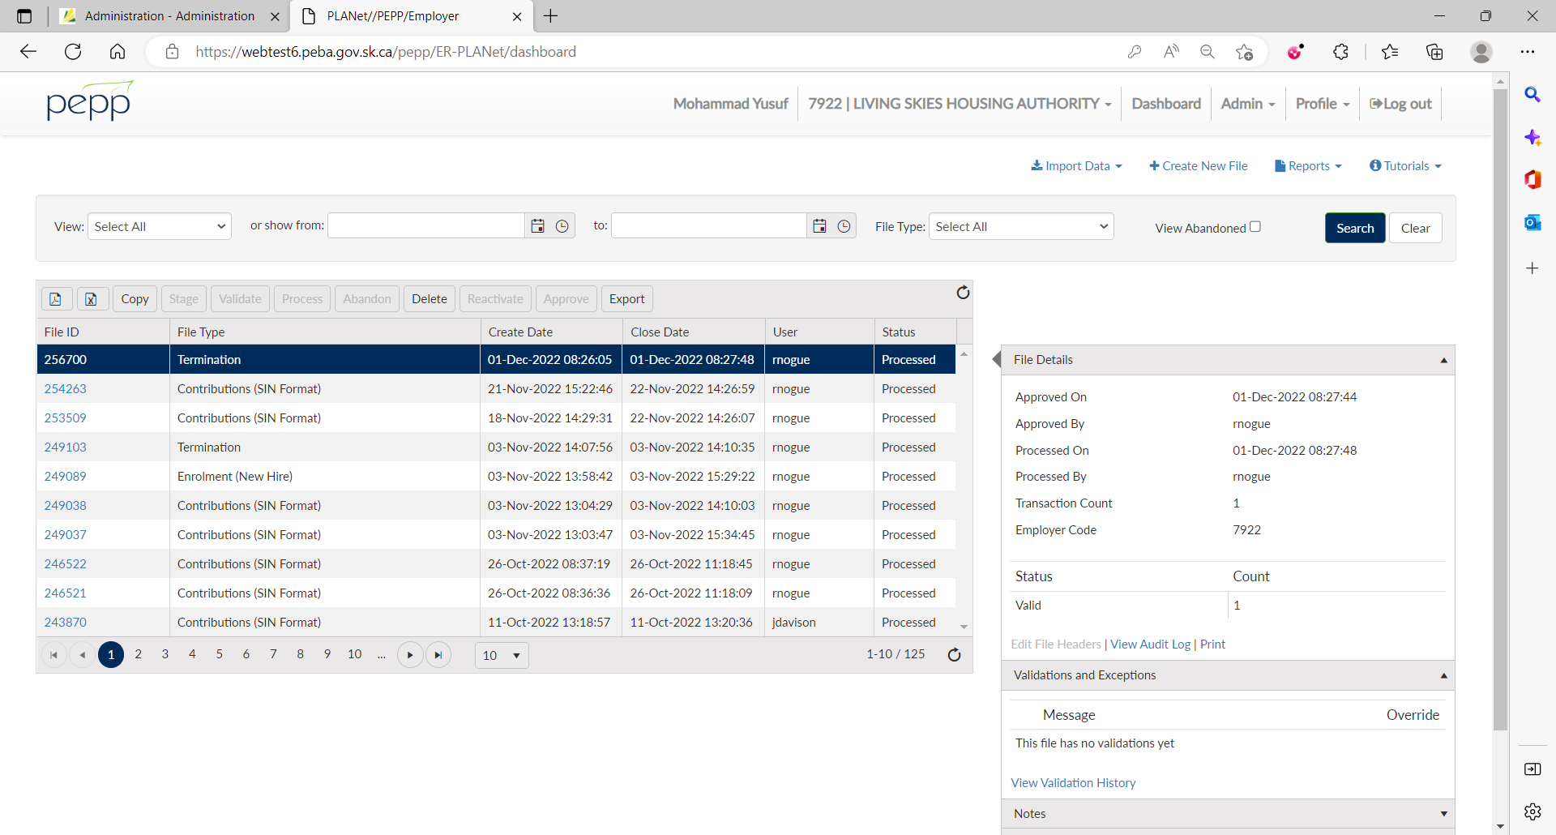

1. Click Import Data.

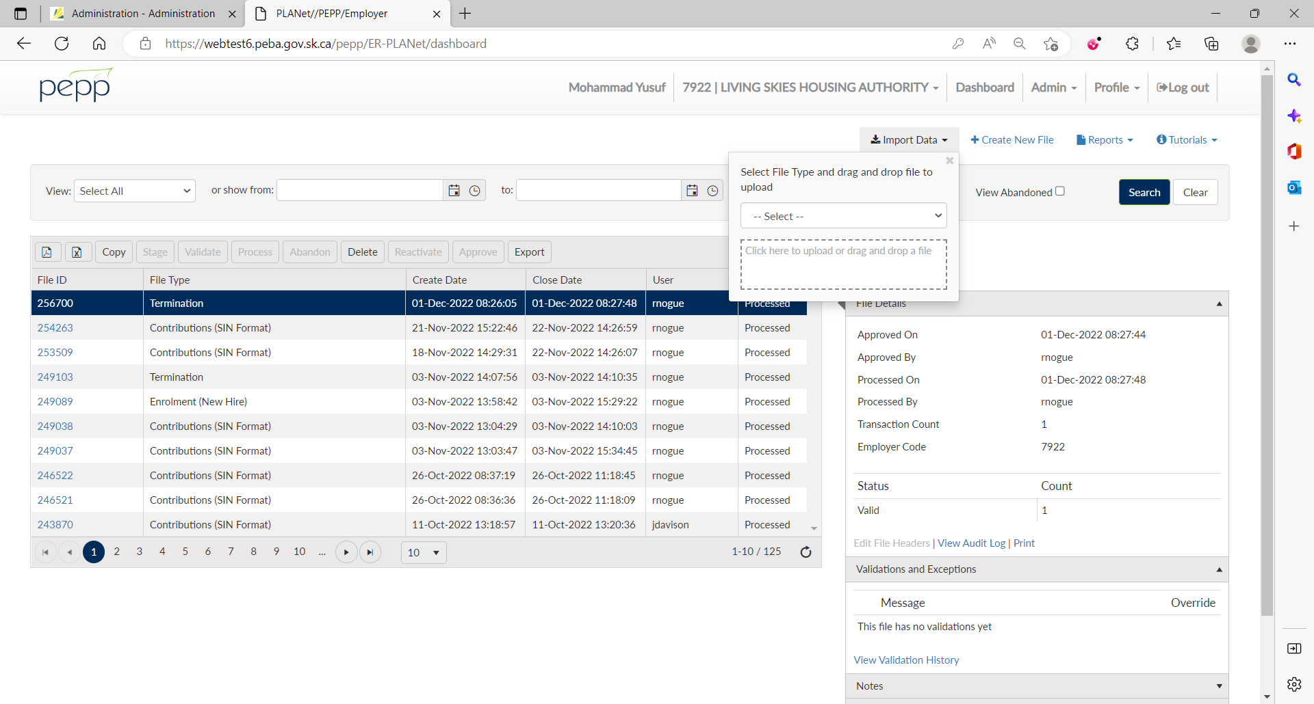

1. From the dropdown, select Contribution (SIN Format) to upload a contribution via SIN.

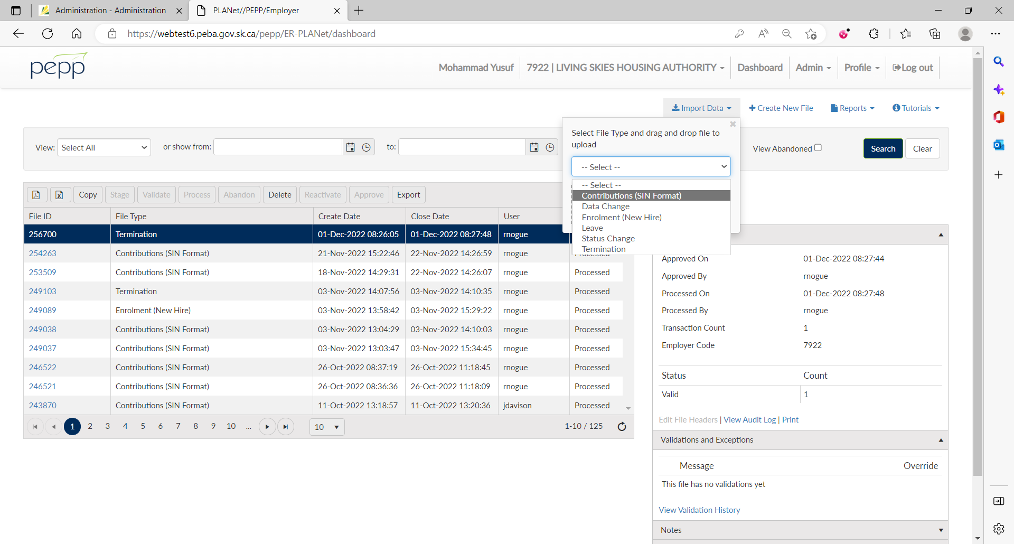

1. Click to browse and upload a CSV file or drag and drop a CSV file.

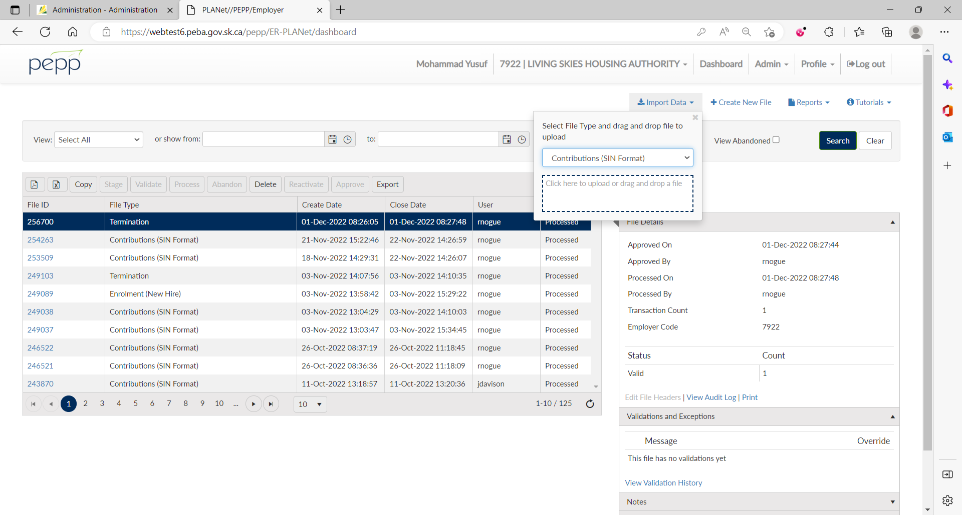

Actual file using the notepad

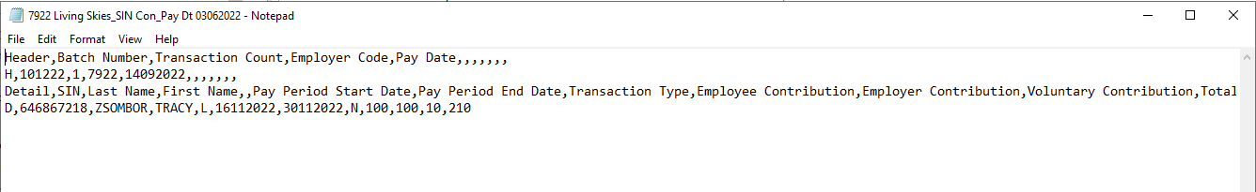  
Sample CSV file

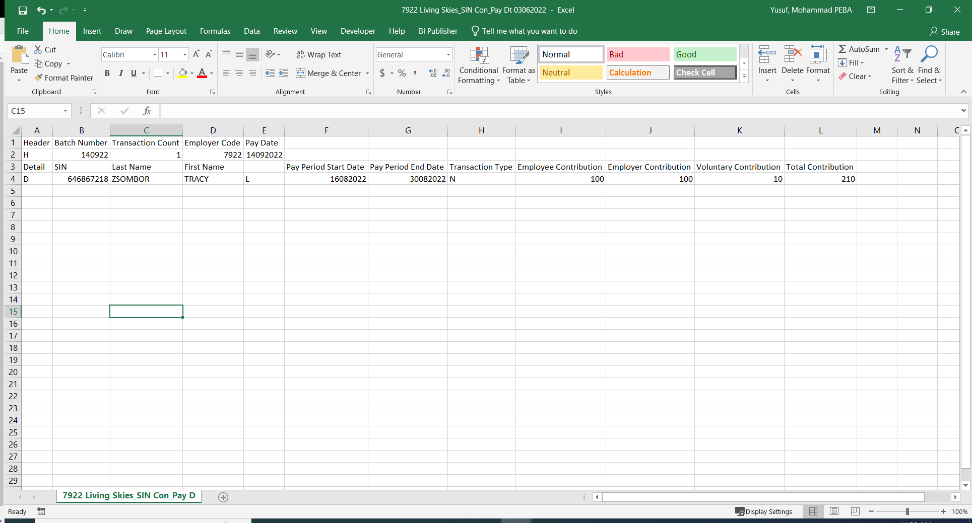

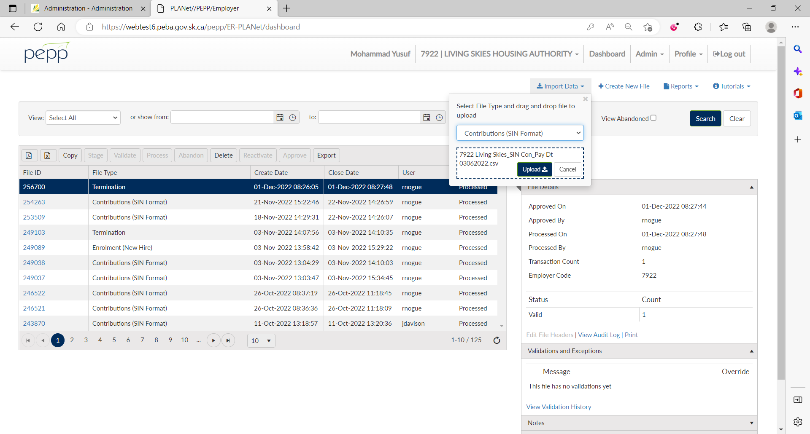

1. Under File Details, click on Stage.

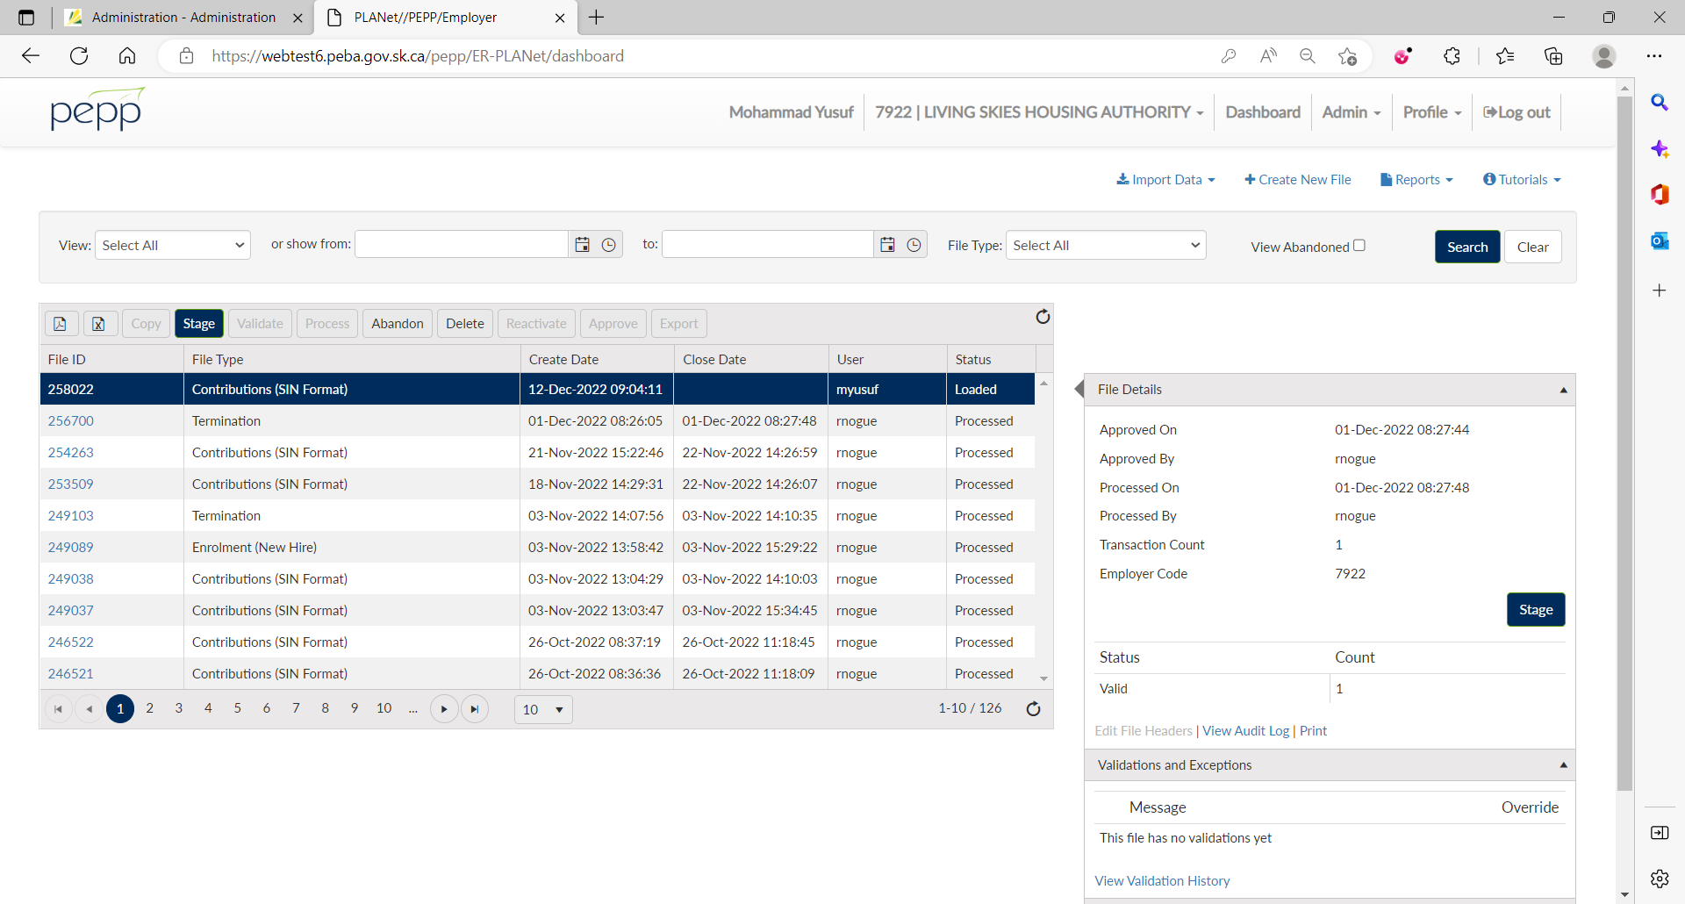

1. Click on Validate.

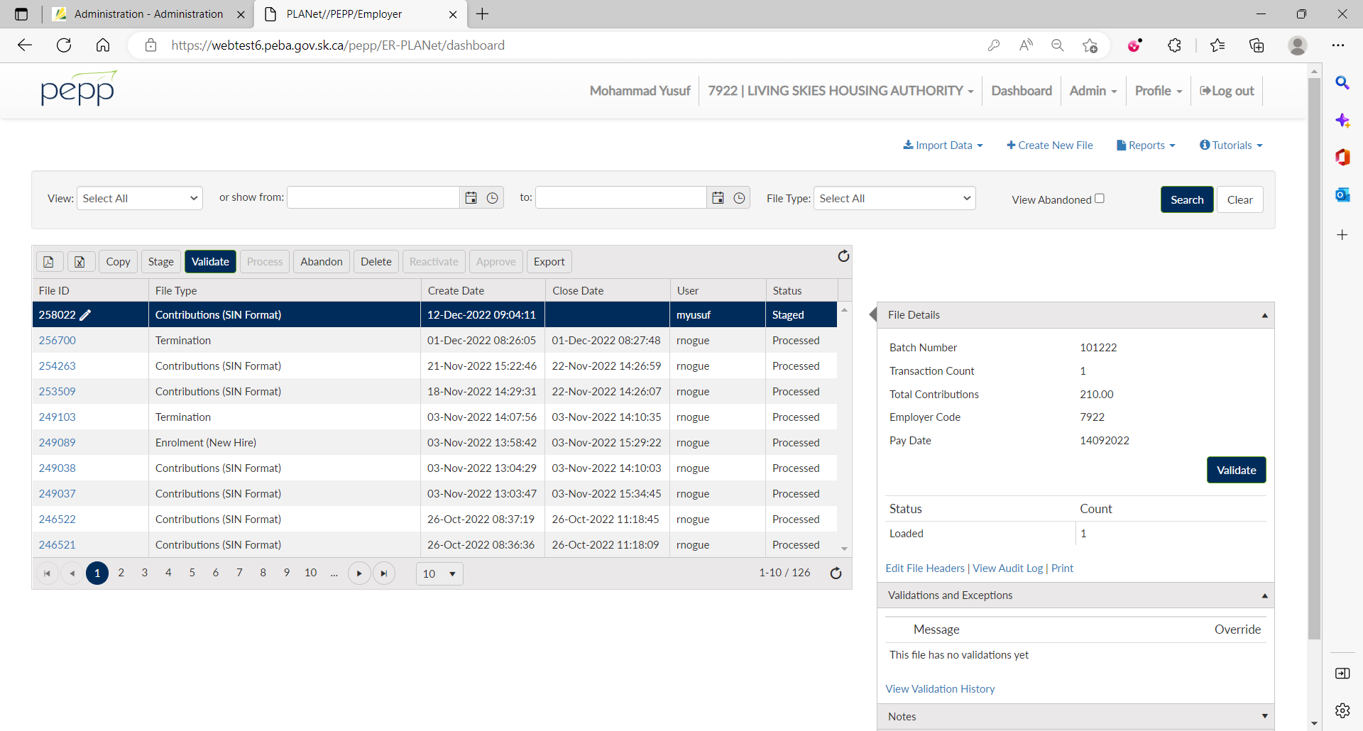

1. Click on Approve.

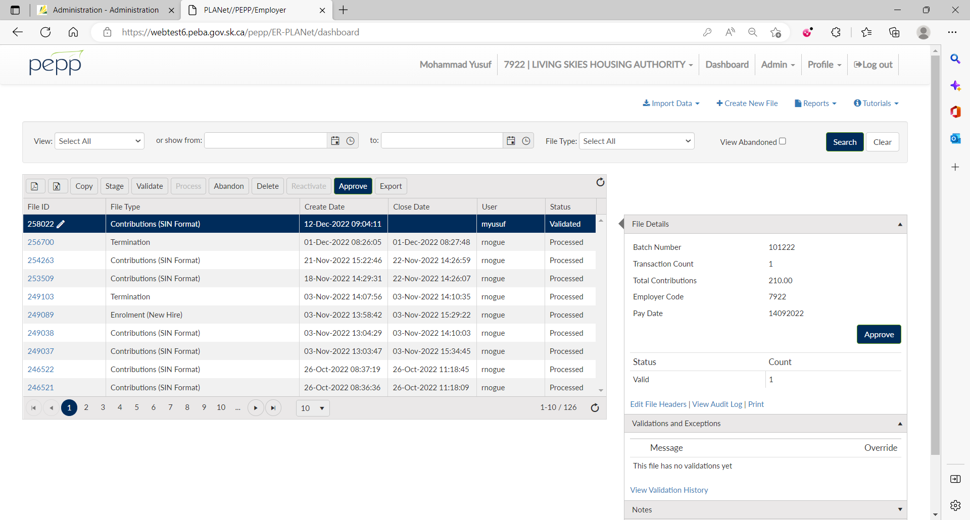

1. Click on Process.

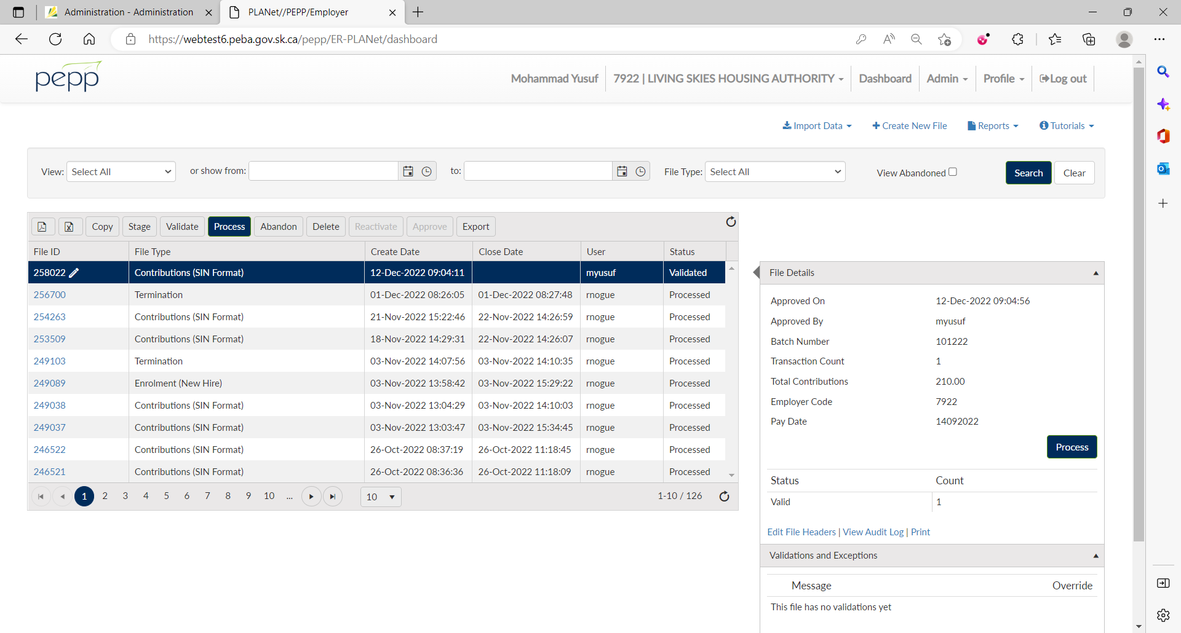

1. File status is now Processed.

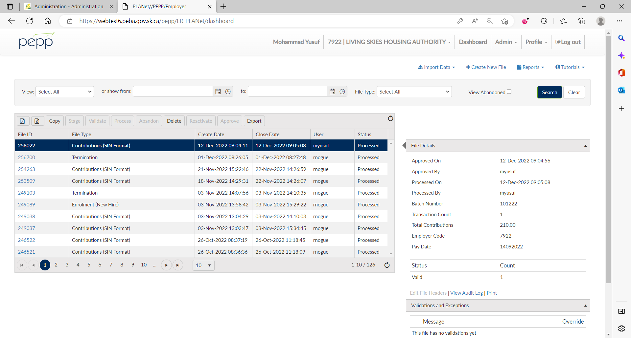

1. Log into Penfax and got to Batches -> Data Posting Batches.

Search with the employer. You can see the Contribution file you just processed through DCT.

Click on the Data Posting Batch ID and Go to Pending tab.

System triggers 3 errors – 1 for PEPP Receipt Date and 2 for remittance.

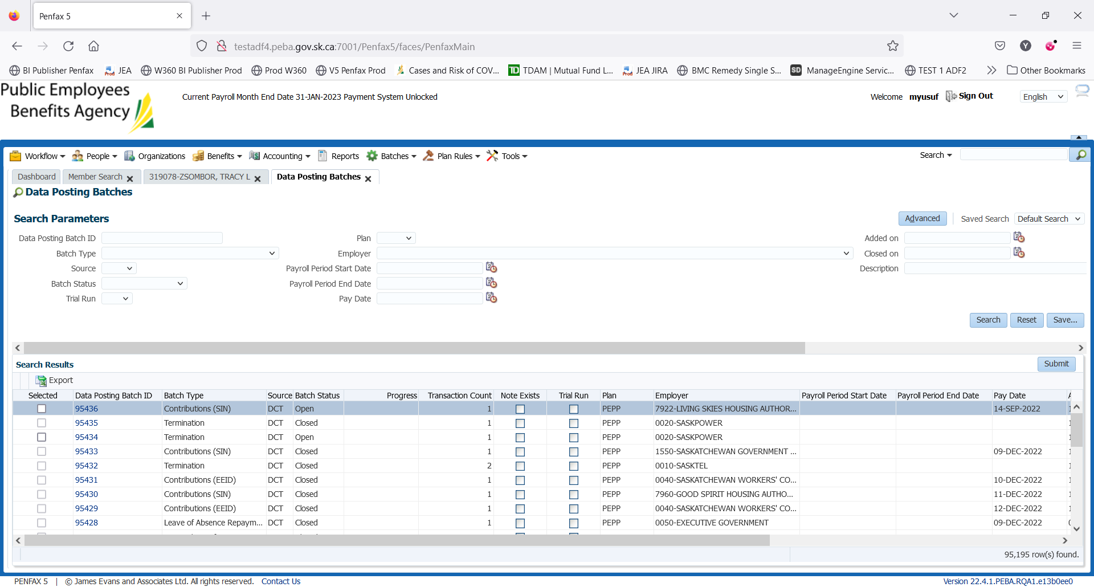

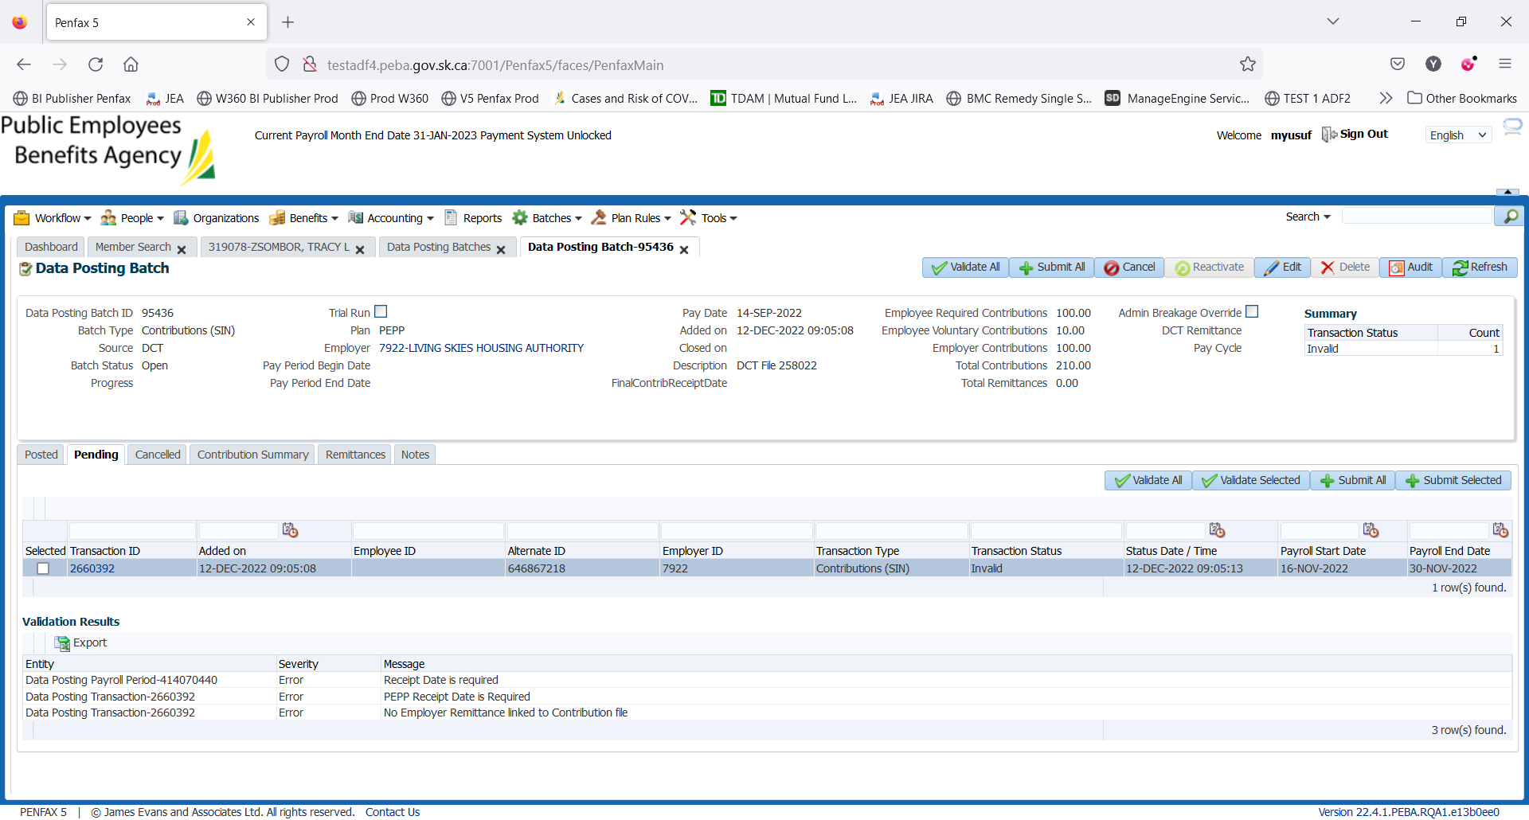

1. Go to Remittances tab and click Add to link the remittance to the data posting batch.

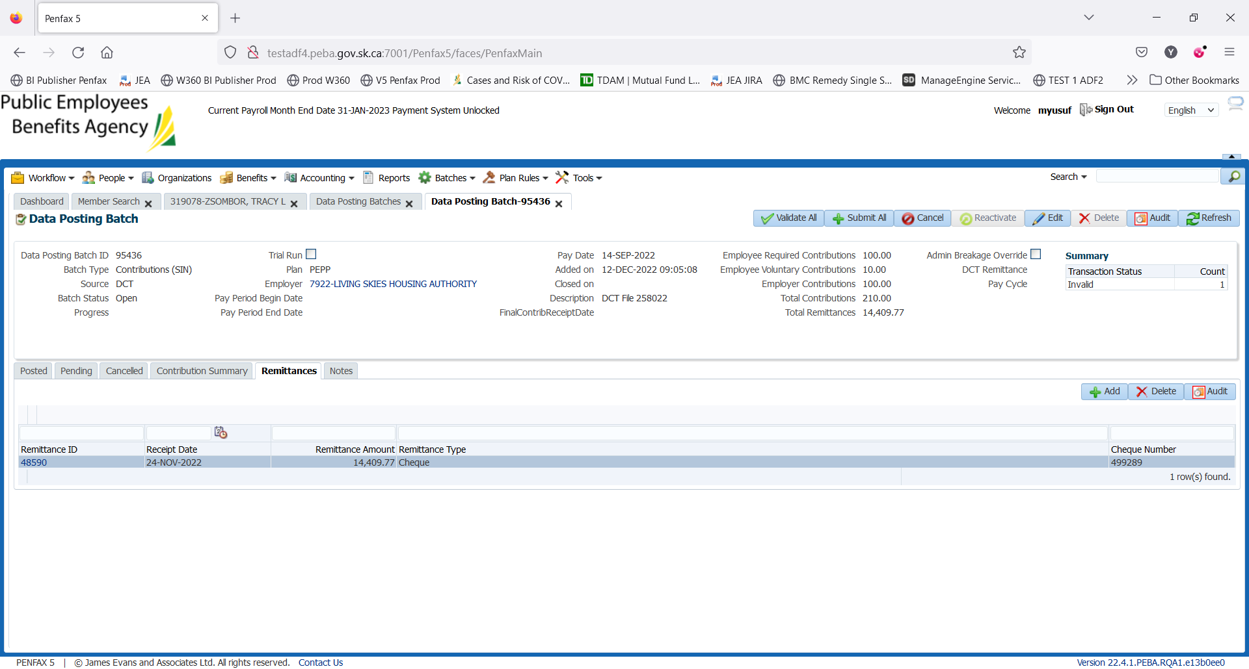

1. Click Edit on the top and add PEPP Receipt Date.

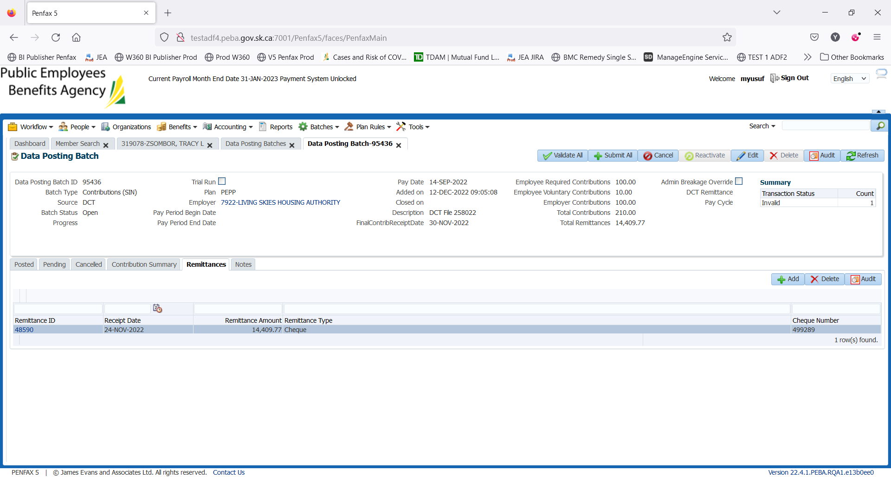

1. Now, go to Pending tab and validate all the transaction records by clicking on Validate All.

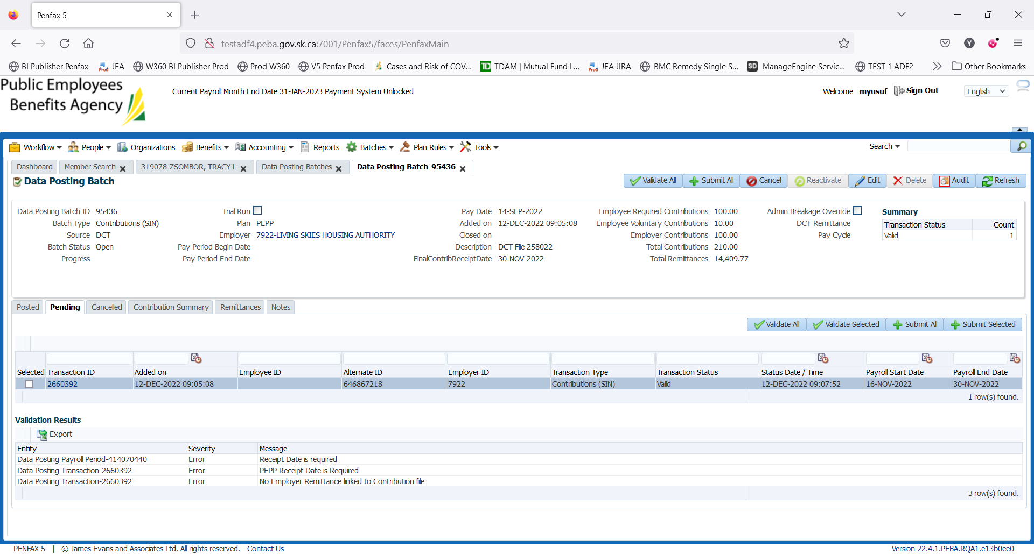

1. Now, submit all the transaction records by clicking on Submit All.

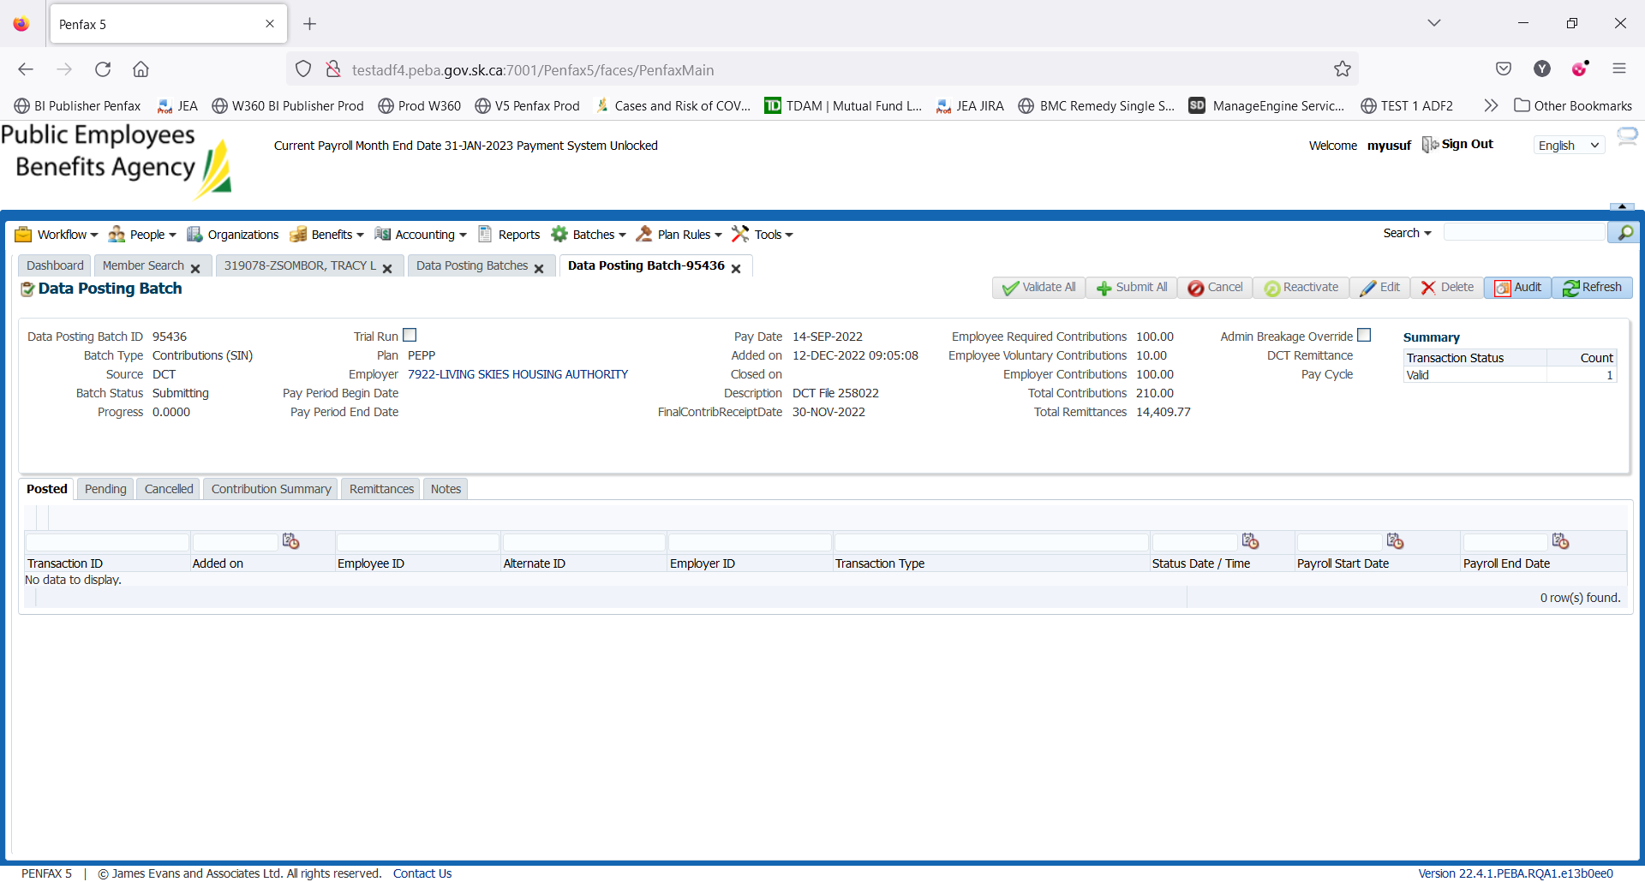

1. Records have been posted and so can be found under Posted tab now.

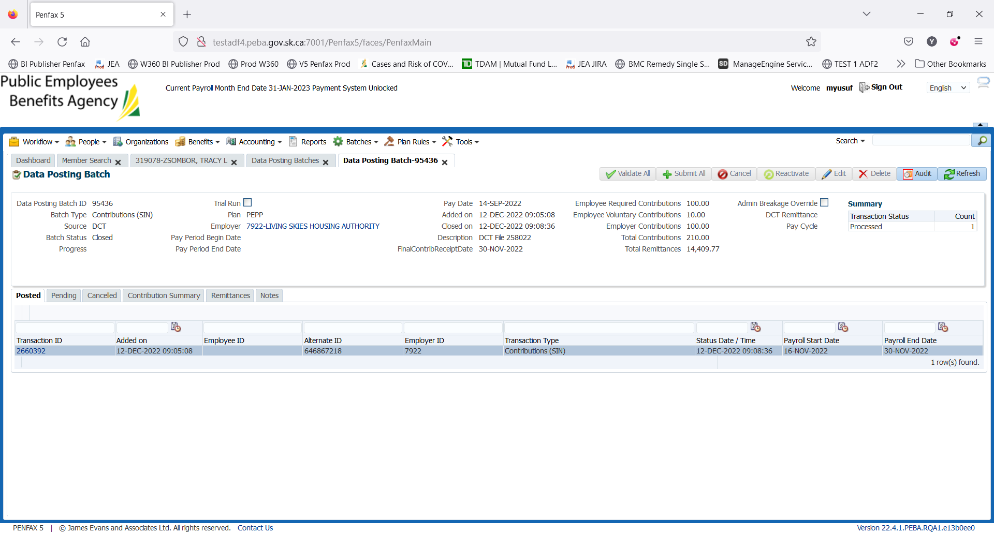

1. Bring up the members for whom contributions have posted. Go to Member Profile -> Contribution History. Contribution has been posted to member’s account.

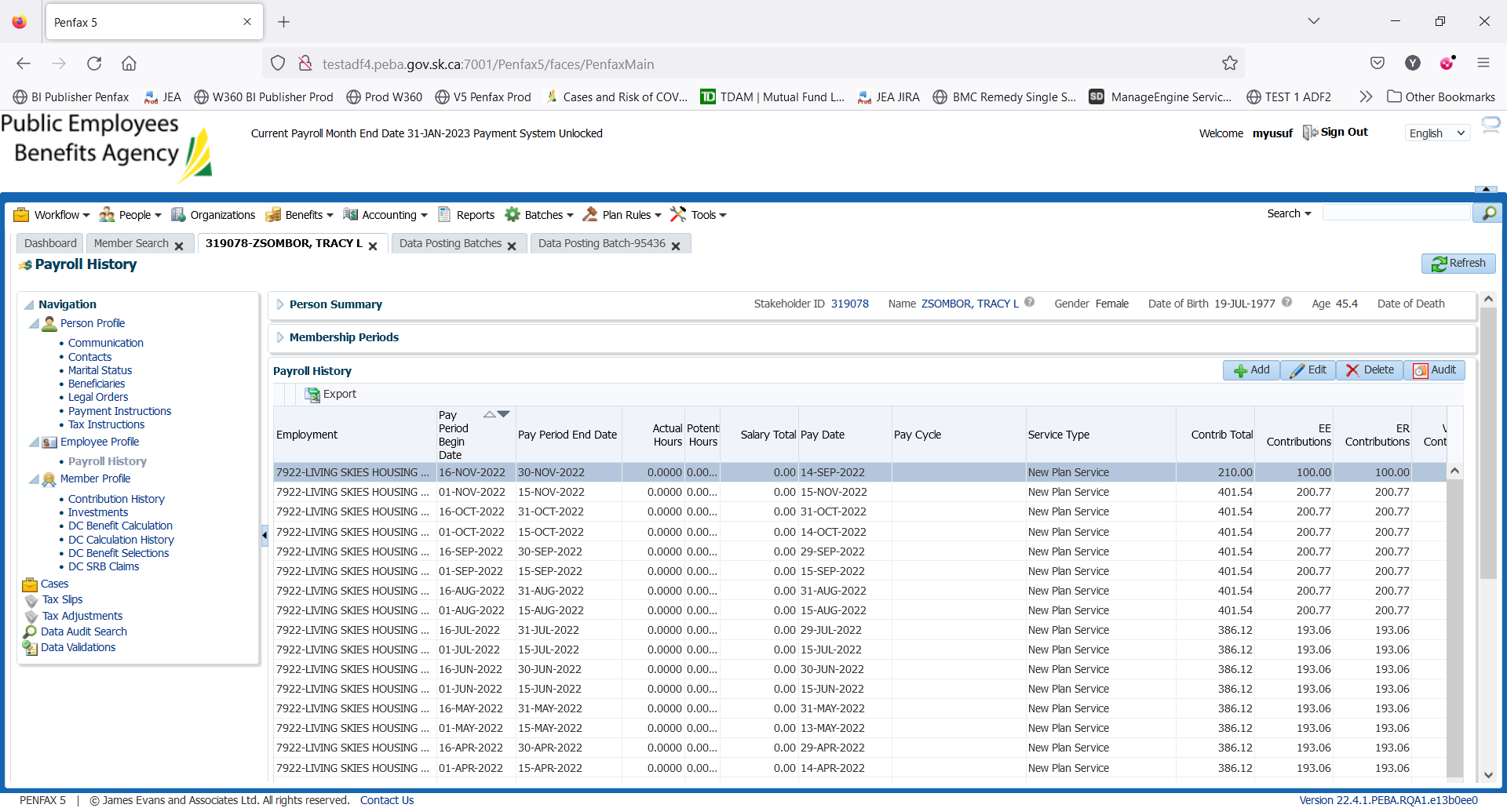

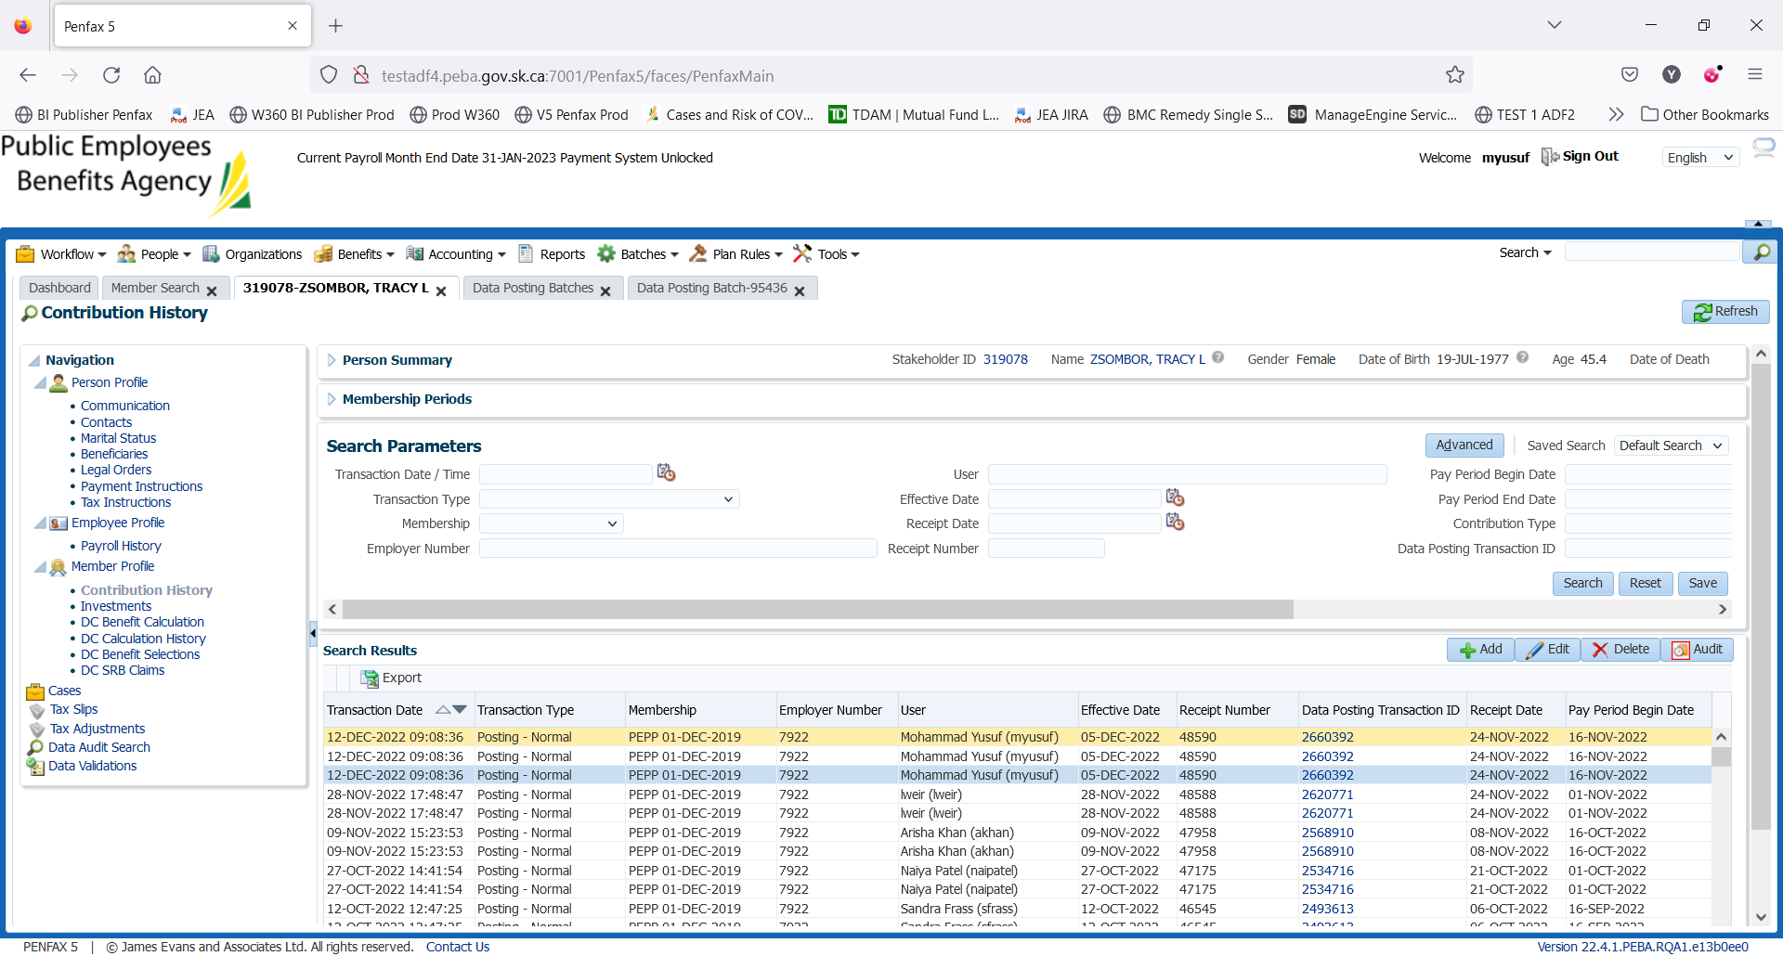

1. Go to Payroll History where you can find the posted contribution amount.

DAY 2

1. Wait for the PIT batch to run overnight.
2. Bring up a member in Penfax and go to Investments. Yesterday’s processed contribution can be seen under Account Activity.

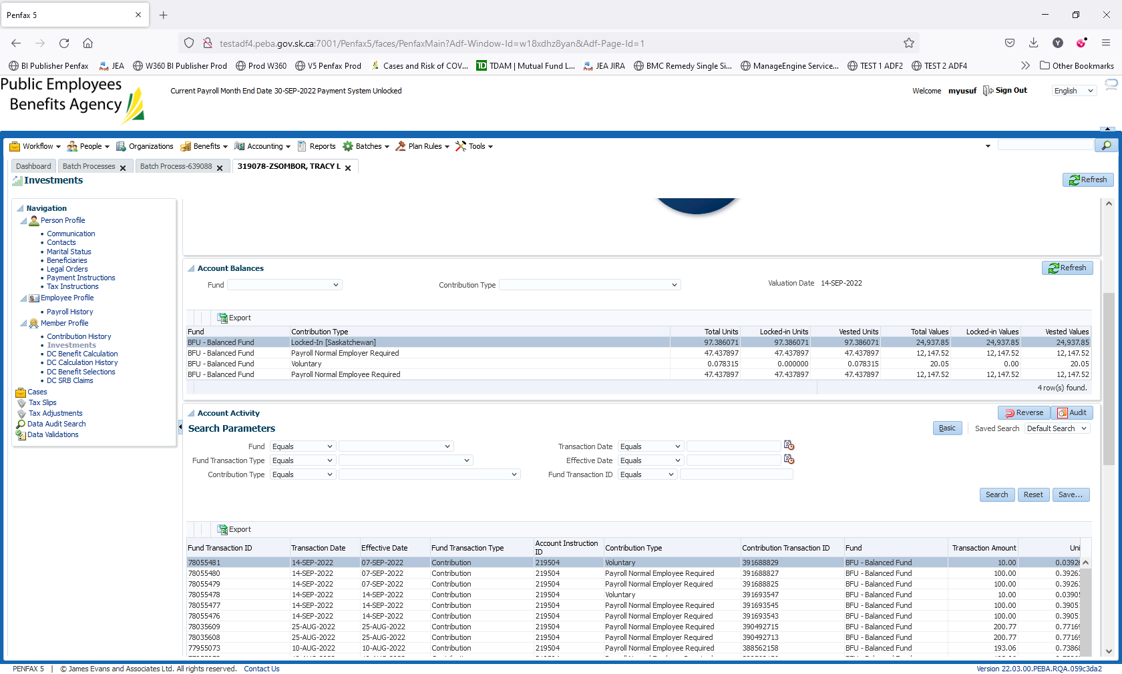

1. Go to Batches -> Batch Processes. Search for PEPP Valuation Report and open the first one.

For SID: 319078, $210.0 contribution posted into BFU under the employer Living Skies Housing Authority that can be seen on Section Two tab.

